1.Develop OpenGL program to draw a line using Bresenham’s algorithm for all types of slopes.
from OpenGL.GL import *
from OpenGL.GLU import *
from OpenGL.GLUT import *

# Window size
WIDTH, HEIGHT = 600, 600

# Line endpoints (change these to test different slopes)
x1, y1 = -200, -100
x2, y2 = 200, 150

def bresenham_line(x1, y1, x2, y2):
"""Bresenham's Line Drawing Algorithm (all slopes)"""

dx = abs(x2 - x1)
dy = abs(y2 - y1)

x, y = x1, y1

# Direction
sx = 1 if x2 > x1 else -1
sy = 1 if y2 > y1 else -1

# Case 1: |slope| < 1
if dx > dy:
p = 2 * dy - dx
for _ in range(dx + 1):
glVertex2i(x, y)
x += sx
if p >= 0:
y += sy
p -= 2 * dx
p += 2 * dy

# Case 2: |slope| >= 1
else:
p = 2 * dx - dy
for _ in range(dy + 1):
glVertex2i(x, y)
y += sy
if p >= 0:
x += sx
p -= 2 * dy
p += 2 * dx

def display():
glClear(GL_COLOR_BUFFER_BIT)

glColor3f(1.0, 1.0, 1.0) # White color
glPointSize(3.0)

glBegin(GL_POINTS)
bresenham_line(x1, y1, x2, y2)
glEnd()

glFlush()

def init():
glClearColor(0.0, 0.0, 0.0, 1.0) # Black background
gluOrtho2D(-300, 300, -300, 300) # Coordinate system

def main():
glutInit()
glutInitDisplayMode(GLUT_SINGLE | GLUT_RGB)
glutInitWindowSize(WIDTH, HEIGHT)
glutInitWindowPosition(100, 100)
glutCreateWindow(b"Bresenham Line Drawing - All Slopes")

init()
glutDisplayFunc(display)
glutMainLoop()

if __name__ == "__main__":
main()

OUTPUT: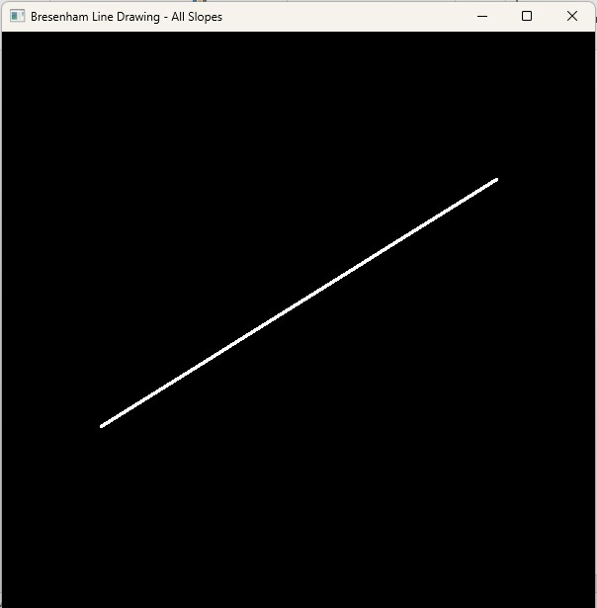

2. Develop OpenGL program to create and rotate a triangle about the origin and a fixed point.
from OpenGL.GL import *
from OpenGL.GLU import *
from OpenGL.GLUT import *
import math

# Window size
WIDTH, HEIGHT = 600, 600

# Triangle vertices
triangle = [[100, 100], [200, 100], [150, 200]]

angle = 0 # rotation angle

# Fixed point (pivot)
pivot = [50, 50]

def draw_triangle(points):
"""Draw triangle using given points"""
glBegin(GL_TRIANGLES)
for x, y in points:
glVertex2f(x, y)
glEnd()

def rotate_origin(points, angle):
"""Rotate triangle about origin (0,0)"""
rad = math.radians(angle)
cos_a = math.cos(rad)
sin_a = math.sin(rad)

new_points = []
for x, y in points:
x_new = x * cos_a - y * sin_a
y_new = x * sin_a + y * cos_a
new_points.append([x_new, y_new])

return new_points

def rotate_fixed(points, angle, pivot):
"""Rotate triangle about a fixed point"""
rad = math.radians(angle)
cos_a = math.cos(rad)
sin_a = math.sin(rad)

px, py = pivot
new_points = []

for x, y in points:
# Step 1: Translate to origin
x -= px
y -= py

# Step 2: Rotate
x_new = x * cos_a - y * sin_a
y_new = x * sin_a + y * cos_a

# Step 3: Translate back
x_new += px
y_new += py

new_points.append([x_new, y_new])

return new_points

def display():
global angle

glClear(GL_COLOR_BUFFER_BIT)

# Original triangle (white)
glColor3f(1, 1, 1)
draw_triangle(triangle)

# Rotation about origin (red)
glColor3f(1, 0, 0)
rot_origin = rotate_origin(triangle, angle)
draw_triangle(rot_origin)

# Rotation about fixed point (green)
glColor3f(0, 1, 0)
rot_fixed = rotate_fixed(triangle, angle, pivot)
draw_triangle(rot_fixed)

glFlush()

def update(value):
global angle
angle += 2
if angle > 360:
angle = 0

glutPostRedisplay()
glutTimerFunc(30, update, 0)

def init():
glClearColor(0, 0, 0, 1)
gluOrtho2D(-300, 300, -300, 300)

def main():
glutInit()
glutInitDisplayMode(GLUT_SINGLE | GLUT_RGB)
glutInitWindowSize(WIDTH, HEIGHT)
glutInitWindowPosition(100, 100)
glutCreateWindow(b"Triangle Rotation (Origin & Fixed Point)")

init()
glutDisplayFunc(display)
glutTimerFunc(30, update, 0)
glutMainLoop()

if __name__ == "__main__":
main()


